CREATE VIEW Average_February_Deaths AS SELECT AVG(total_deaths) FROM covid_deaths.coviddeaths WHERE date between '2/1/2020' AND '2/28/2020';

CREATE VIEW Average_April_Deaths AS SELECT AVG(total_deaths) FROM covid_deaths.coviddeaths WHERE date between '4/1/2020' AND '4/30/2020';

CREATE VIEW Average_May_Deaths AS SELECT AVG(total_deaths) FROM covid_deaths.coviddeaths WHERE date between '5/1/2020' AND '5/31/2020';

CREATE VIEW Average_June_Deaths AS SELECT AVG(total_deaths) FROM covid_deaths.coviddeaths WHERE date between '6/1/2020' AND '6/30/2020';

CREATE VIEW Average_July_Deaths AS SELECT AVG(total_deaths) FROM covid_deaths.coviddeaths WHERE date between '7/1/2020' AND '7/31/2020';

CREATE VIEW Average_August_Deaths AS SELECT AVG(total_deaths) FROM covid_deaths.coviddeaths WHERE date between '8/1/2020' AND '8/31/2020';

CREATE VIEW Average_September_Deaths AS SELECT AVG(total_deaths) FROM covid_deaths.coviddeaths WHERE date between '9/1/2020' AND '9/30/2020';

CREATE VIEW Average_October_Deaths AS SELECT AVG(total_deaths) FROM covid_deaths.coviddeaths WHERE date between '10/1/2020' AND '10/31/2020';

CREATE VIEW Average_November_Deaths AS SELECT AVG(total_deaths) FROM covid_deaths.coviddeaths WHERE date between '11/1/2020' AND '11/30/2020';

CREATE VIEW Average_December_Deaths AS SELECT AVG(total_deaths) FROM covid_deaths.coviddeaths WHERE date between '12/1/2020' AND '12/31/2020';

Visualized In Tableau:

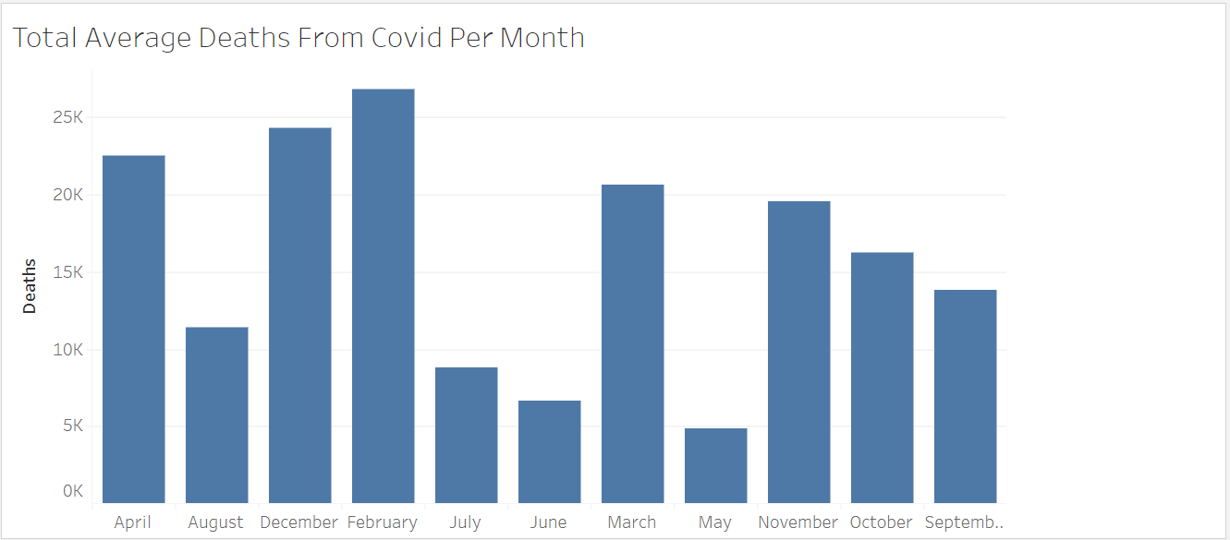

#Shows the likelihood of dying if one contracts covid

CREATE VIEW date_death_percentage AS SELECT date, (total_deaths/total_cases)*100 FROM covid_deaths.coviddeaths;

SELECT MAX(total_deaths), MAX(total_vaccinations), location FROM covid_deaths.coviddeaths GROUP BY location ORDER BY MAX(total_vaccinations) DESC;

CREATE VIEW Max_Deaths_Per_Vaccination_Percentage AS SELECT (MAX(total_deaths) / MAX(total_vaccinations)) * 100 , location, date FROM covid_deaths.coviddeaths GROUP BY continent, location ORDER BY MAX(total_vaccinations) DESC;

#Shows how many are dying out of the total that get covid

CREATE VIEW total_percent_dying_from_covid AS SELECT SUM(new_deaths), SUM(new_cases), (SUM(new_deaths)/SUM(new_cases)) * 100 as death_percentage_world_wide FROM covid_deaths.coviddeaths;

//////////////////////////////////////////////

Create View PercentPopulationVaccinated as

Select dea.continent, dea.location, dea.date, dea.population, vac.new_vaccinations

, SUM(cast(vac.new_vaccinations AS DOUBLE)) OVER (Partition by dea.Location Order by dea.location, dea.Date) as RollingPeopleVaccinated

From coviddeaths dea

Join covidvaccinations vac

On dea.location = vac.location

and dea.date = vac.date

where dea.continent is not null

, (RollingPeopleVaccinated/population)*100

From coviddeaths dea

Join covidvaccinations vac

On dea.location = vac.location

and dea.date = vac.date

where dea.continent is not null

LOAD DATA LOCAL INFILE 'C:\Users\DevLaptop\Contacts\DataSciencePortfolio\CovidVaccinations' INTO TABLE `covid_deaths`.`covidvaccinations` FIELDS TERMINATED BY ',' LINES TERMINATED BY '\n' (ï»¿iso_code, continent, location, date, new_tests, total_tests, total_tests_per_thousand, new_tests_per_thousand, new_tests_smoothed, new_tests_smoothed_per_thousand, positive_rate, tests_per_case, tests_units, total_vaccinations, people_vaccinated, people_fully_vaccinated, new_vaccinations, new_vaccinations_smoothed, total_vaccinations_per_hundred, people_vaccinated_per_hundred, people_fully_vaccinated_per_hundred, new_vaccinations_smoothed_per_million, stringency_index, population_density, median_age, aged_65_older, aged_70_older, gdp_per_capita, extreme_poverty, cardiovasc_death_rate, diabetes_prevalence, female_smokers, male_smokers, handwashing_facilities, hospital_beds_per_thousand, life_expectancy, human_development_index);

Error Code: 2. File 'C:UsersDevLaptopContactsDataSciencePortfolioCovidVaccinations' not found (OS errno 2 - No such file or directory)

Error Code: 2. File 'C:\Users\DevLaptop\Contacts\DataSciencePortfolio\CovidVaccinations' not found (OS errno 2 - No such file or directory)

Error Code: 2. File 'C:\Users\DevLaptop\Desktop\CovidVaccinations' not found (OS errno 2 - No such file or directory)

Make sure that you add .csv to the end and add \\ where there would normally be one

LOAD DATA LOCAL INFILE 'C:\\Users\\DevLaptop\\Desktop\\CovidVaccinations.csv' INTO TABLE `covid_deaths`.`covidvaccinations` FIELDS TERMINATED BY ',' LINES TERMINATED BY '\n' (ï»¿iso_code, continent, location, date, new_tests, total_tests, total_tests_per_thousand, new_tests_per_thousand, new_tests_smoothed, new_tests_smoothed_per_thousand, positive_rate, tests_per_case, tests_units, total_vaccinations, people_vaccinated, people_fully_vaccinated, new_vaccinations, new_vaccinations_smoothed, total_vaccinations_per_hundred, people_vaccinated_per_hundred, people_fully_vaccinated_per_hundred, new_vaccinations_smoothed_per_million, stringency_index, population_density, median_age, aged_65_older, aged_70_older, gdp_per_capita, extreme_poverty, cardiovasc_death_rate, diabetes_prevalence, female_smokers, male_smokers, handwashing_facilities, hospital_beds_per_thousand, life_expectancy, human_development_index);

LOAD DATA LOCAL INFILE 'C:\\Users\\DevLaptop\\Desktop\\CovidDeaths.csv' INTO TABLE `covid_deaths`.`coviddeaths` FIELDS TERMINATED BY ',' LINES TERMINATED BY '\n' (ï»¿iso_code, continent, location, date, total_cases, new_cases, new_cases_smoothed, total_deaths, new_deaths, new_deaths_smoothed, total_cases_per_million, new_cases_per_million, new_cases_smoothed_per_million, total_deaths_per_million, new_deaths_per_million, new_deaths_smoothed_per_million, reproduction_rate, icu_patients, icu_patients_per_million, hosp_patients, hosp_patients_per_million, weekly_icu_admissions, weekly_icu_admissions_per_million, weekly_hosp_admissions, weekly_hosp_admissions_per_million, new_tests, total_tests, total_tests_per_thousand, new_tests_per_thousand, new_tests_smoothed, new_tests_smoothed_per_thousand, positive_rate, tests_per_case, tests_units, total_vaccinations, people_vaccinated, people_fully_vaccinated, new_vaccinations, new_vaccinations_smoothed, total_vaccinations_per_hundred, people_vaccinated_per_hundred, people_fully_vaccinated_per_hundred, new_vaccinations_smoothed_per_million, stringency_index, population, population_density, median_age, aged_65_older, aged_70_older, gdp_per_capita, extreme_poverty, cardiovasc_death_rate, diabetes_prevalence ,female_smokers, male_smokers, handwashing_facilities, hospital_beds_per_thousand, life_expectancy, human_development_index);

SELECT * FROM covid_deaths.total_percent_dying_from_covid LIMIT 0, 1000